# **Project: Marketing Attribution**

CoolTShirts, an innovative apparel shop, is running a bunch of marketing campaigns. In this project, you’ll be helping them answer these questions about their campaigns:

1. Get familiar with the company.

* How many campaigns and sources does CoolTShirts use and how are they related? Be sure to explain the difference between utm_campaign and utm_source.
* What pages are on their website?

2. What is the user journey?

* How many first touches is each campaign responsible for?
* How many last touches is each campaign responsible for?
* How many visitors make a purchase?
* How many last touches on the purchase page is each campaign responsible for?
* What is the typical user journey?

3. Optimize the campaign budget.

* CoolTShirts can re-invest in 5 campaigns. Which should they pick and why?

**Start**

**Q: How many campaigns and sources does CoolTShirts use and how are they related? Be sure to explain the difference**

Select count(DISTINCT(utm_campaign))  
from page_visits;

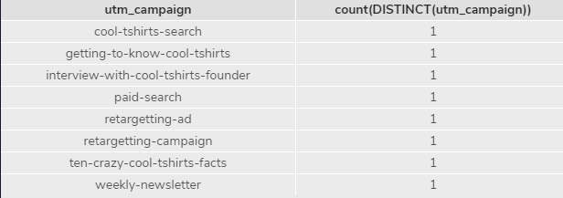

Select count(DISTINCT(utm_source))  
from page_visits;

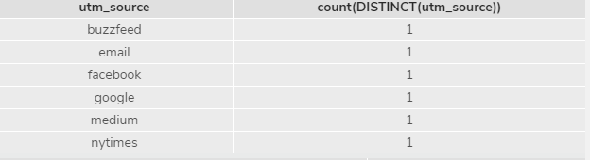

select DISTINCT utm_campaign, utm_source  
from page_visits;

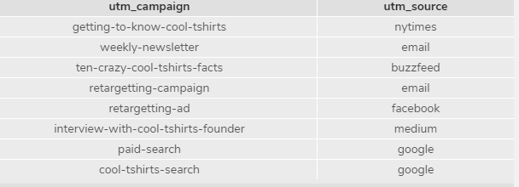

**Q: What pages are on their website?**

select DISTINCT(page_name)  
from page_visits;  
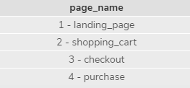

**Q: How many first touches is each campaign responsible for?**

WITH first_touch AS (  
    SELECT user_id,  
       MIN(timestamp) AS 'first_touch_at'  
    FROM page_visits  
    GROUP BY user_id)  
SELECT ft.user_id,  
   ft.first_touch_at,  
   pv.utm_source,

pv.utm_campaign,

count(utm_campaign)  
FROM first_touch AS 'ft'  
JOIN page_visits AS 'pv'  
   ON ft.user_id = pv.user_id  
   AND ft.first_touch_at = pv.timestamp

Group by utm_campaign

Order by 5 desc;

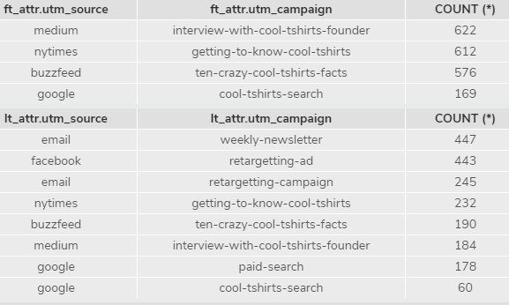

**Q: How many last touches is each campaign responsible for?**

WITH last_touch AS (  
    SELECT user_id,  
       Max(timestamp) AS 'last_touch_at'  
    FROM page_visits  
    GROUP BY user_id)  
SELECT lt.user_id,  
   lt.first_touch_at,  
   pv.utm_source,

pv.utm_campaign,

count(utm_campaign)  
FROM last_touch AS 'lt'  
JOIN page_visits AS 'pv'  
   ON lt.user_id = pv.user_id  
   AND lt.first_touch_at = pv.timestamp

Group by utm_campaign

Order by 5 desc;



**Q: How many visitors make a purchase?**

SELECT  
count ( *)  
from page_visits  
where page_name = ‘4 - purchase’;

5

**Q: How many last touches on the purchase page is each campaign responsible for?**

WITH last_touch AS (  
    SELECT user_id,  
       Max(timestamp) AS 'last_touch_at'  
    FROM page_visits

Where page_name= ‘4 – purchase’  
    GROUP BY user_id)  
SELECT lt.user_id,  
   lt.first_touch_at,  
   pv.utm_source,

pv.utm_campaign,

count(utm_campaign)  
FROM last_touch AS 'lt'  
JOIN page_visits AS 'pv'  
   ON lt.user_id = pv.user_id  
   AND lt.first_touch_at = pv.timestamp

Group by utm_campaign

Order by 5 desc;

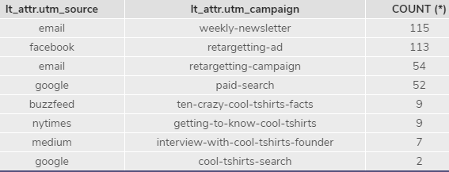

**Q: What is the typical user journey?**

It seems that we are initially attracting visitors to our site through articles places on the NY Times, Buzzfeed and Medium. Our retargeting efforts via Facebook and email, along with the email newsletter, seem to be most successful in encouraging visitors to return to our site who are interested in purchasing our product.

**Q: CoolTShirts can re-invest in 5 campaigns. Which should they pick and why?**

Prior to re-investing in any campaigns, I would conduct further analysis on the checkout page, as it seems there is a significant drop in users in every campaign, and it could be affecting the efficiency and potential of the campaigns.

Whilst this is being checked, I would definitely suggest maintaining the email weekly- newsletter and articles, as articles Medium, Buzzfeed and NY Times prove effective for First Touch. Once the checkout matter is sorted, then I would suggest doing email re-targeting and facebook re-targeting to advertise any changes in the checkout process or revise the demographics of the target audience - depending on what the issue was. The problems identified with the checkout process may also  the paid google search.